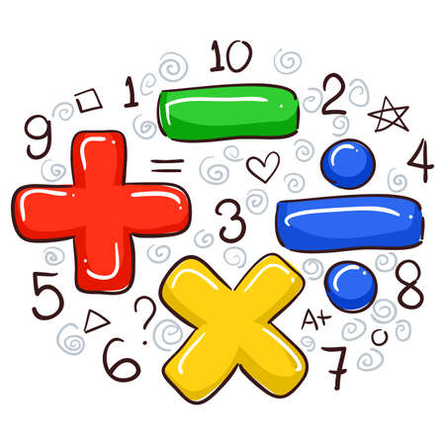
Introducing:
PADLET!!!
Your One-Stop Math Resource Shop
With Padlet you have access to:
- Curriculum Previews
- Math Apps
- Math Activities for Home
- Tutoring Information
- Practice Books
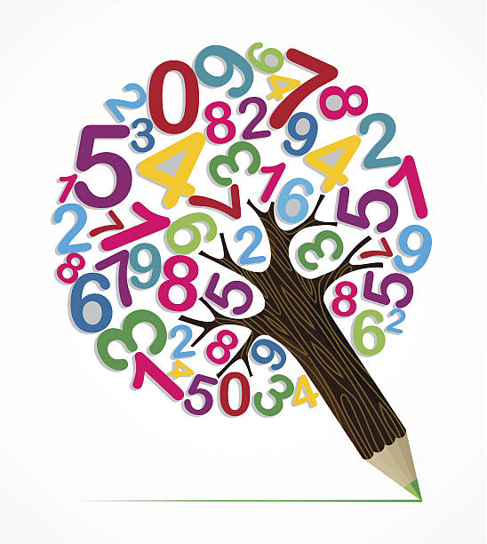
- Online Games and…
Many other Math Resources!

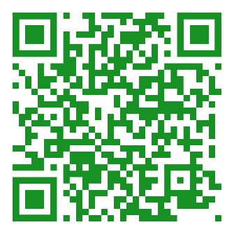

Scan QR Code to Access

